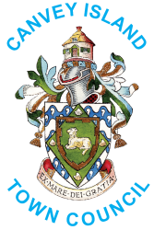
Canvey Island Town Council
Health and Wellbeing Event
BOOKING FORM

Company Name: .........................................

Description of stall: ..................................................................................

...........................................................................................................................

Contact Name: .........................................

Phone: .........................................

Email: .........................................

Please provide your public liability insurance documentation via email to
events@canveyisland-tc.gov.uk

Booking donation amount of £15- Bookings to be paid Via BACS payment

Account Name: Canvey Island Town Council
Account Number: 65262854
Sort Code: 08-92-99

Signature ............................................................... Date ..................................

Please complete this form and return along with your documentation to Canvey Island Town Council either via email events@canveyisland-tc.gov.uk or post to The Paddocks Community Centre, Long Road, Canvey Island, SS8 0JA
Canvey Island Town Council is committed to protecting and safeguarding your personal data. Please refer to the Privacy Notice which can be found on the website www.canveyisland-tc.gov.uk or a hard copy can be provided by the office. In order to comply with the General Data Protection Regulations please complete the attached consent form in order for the Town Council to hold your data.

